How do I complete this project?

1. If you need a refresher on JavaScript syntax, go to the [Javascript Basics course](https://www.udacity.com/course/viewer#!/c-ud804-nd); if you would like to understand how this project is manipulating and traversing the DOM, check out [Intro to jQuery](https://www.udacity.com/course/ud245-nd).
2. Go through the videos and assignments in this course to learn the JavaScript necessary to build your resume.
3. Read all the project details outlined below and make sure you understand each part. If you are unsure of anything please check with your cohort or private message your cohorts coaches.
4. Fork the project repo from [Github](https://github.com/udacity/frontend-nanodegree-resume) and begin building you resume.
5. Review your work against the Project Rubric (on the next page).
6. When you are satisfied with your project, submit it according to the Submission Instructions on the next page.

And your repository will include the following files:

* index.html: The main HTML document. Contains links to all of the CSS and JS resources needed to render the resume, including resumeBuilder.js.
* js/helper.js: Contains helper code needed to format the resume and build the map. It also has a few function shells for additional functionality. More on helper.js further down.
* js/resumeBuilder.js: This file is empty. You should write your code here.
* js/jQuery.js: The jQuery library.
* css/style.css: Contains all of the CSS needed to style the page.
* README.md: The GitHub readme file.
* and some images in the images directory.

1. By the end: Your resume will look something like this 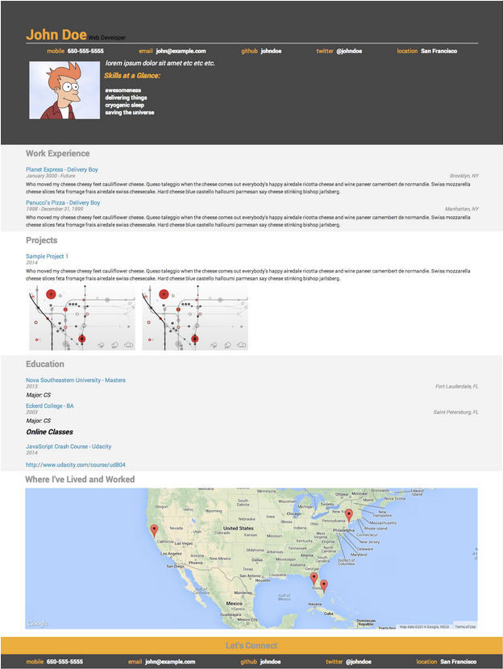

Your starting point...

js/helper.js

Within helper.js, you’ll find a large collection of strings containing snippets of HTML. Within many snippets, you’ll find placeholder data in the form of %data% or %contact%.

Each string has a title that describes how it should be used. For instance, HTMLworkStart should be the first <div> in the Work section of the resume. HTMLschoolLocation contains a %data% placeholder which should be replaced with the location of one of your schools.

Your process:

The resume has four distinct sections: work, education, projects and a header with biographical information. You’ll need to:

1. Build four JSONs, each one representing a different resume section, The objects that you create need to follow the names within the schema exactly:
   * **bio contains:**
   * name : string
   * role : string
   * contacts : an object with
   * mobile: string
   * email: string
   * github: string
   * twitter: string
   * location: string
   * welcomeMessage: string
   * skills: array of strings
   * biopic: url
   * display: function
   * **education contains:**
   * schools: array of objects with
   * name: string
   * location: string
   * degree: string
   * majors: array of strings
   * dates: integer (graduation date)
   * url: string
   * onlineCourses: array with
   * title: string
   * school: string
   * date: integer (date finished)
   * url: string
   * display: function
   * **work contains**
   * jobs: array of objects with
   * employer: string
   * title: string
   * location: string
   * dates: string (works with a hyphen between them)
   * description: string
   * display: function
   * **projects contains:**
   * projects: array of objects with
   * title: string
   * dates: string (works with a hyphen between them)
   * description: string
   * images: array with string urls
   * display: function
2. Iterate through each JSON and append its information to index.html in the correct section.
   * First off, you’ll be using jQuery’s selector.append() and selector.prepend() functions to modify index.html. selector.append() makes an element appear at the end of a selected section. selector.prepend() makes an element appear at the beginning of a selected section.
   * Pay close attention to the ids of the <div>s in index.html and the HTML snippets in helper.js. They’ll be very useful as jQuery selectors for selector.append() and selector.prepend()
   * You’ll also be using the JavaScript method string.replace(old, new) to swap out all the placeholder text (e.g. %data%) for data from your resume JSONs.
   * Here’s an example of some code that would add the location of one your companies to the page:
   * var formattedLocation = HTMLworkLocation.replace("%data%", work.jobs[job].location);
   * $(".work-entry:last").append(formattedLocation);
   * Use the mockup at the bottom of this document as a guide for the order in which you should append elements to the page.
3. The resume includes an interactive map. To add it, append the googleMap string to <div id=”mapDiv”>.
4. All of your code for adding elements to the resume should be within functions. And all of your functions should be encapsulated within the same objects containing your resume data. For instance, your functions for appending work experience elements to the page should be found within the same object containing data about your work experience.
5. Your resume should also console.log() information about click locations. On line 90 in helper.js, you’ll find a jQuery onclick handler that you’ll need to modify to work with the logClicks(x,y) function above it.
6. It’s possible to make additional information show up when you click on the pins in the map. Check out line 174 in helper.js and the Google Maps API to get started.

Create a text file with a list of websites, books, forums, blog posts, Github repositories etc. that you referred to or used in this submission (Add N/A if you did not use such resources).